**The Managerial/Executive Position Abroad (Outside US)**

* **Project Description:** Describe the overall project being managed or managed

Genpact helped Pfizer Inc. to deploy 100+ RPA Bots in their Finance and Accounting department. This helped the client to optimize productivity (reduce FTEs) and improve the overall accuracy of financial transactions manually processed by the team.

* **Job Duties:** Describe the managerial job duties in greater detail from what was already provided in the initial support letter. To ensure the appropriate amount of specificity, please break down the categories such that no category accounts for more than 40% of the total. **Identify and focus on the managerial decisions required for each job duty.**

|  |  |  |
| --- | --- | --- |
| **Job Duties** | **Additional Details Regarding Job Duties** | **% of time spent on job duty (approx.)** |
| Client relationship | Work with client on smooth delivery of existing digital projects and adhere to quality and timely delivery.  Recurring meetings with client are setup to ensure Governance model is functioning well and Genpact is able to deliver what was committed in the contract.  Work with client on high level pipeline for current year.  Work with client stakeholders to create the high level pipeline for next year during last quarter.  Ensure timely governance updates are sent to client on project progress and any concerns raised by the client are address in a timely manner. | 30% |
| Project Governance | Daily war room - Genpact provided updates on the progress of RPA BOTs development  Work on presentation deck and present to Business stakeholders  Work on action items from the meeting and track them to closure  Co-ordinate weekly Stakeholder Meetings for the project  Create detailed project plan and align team members to share the weekly progress with client and internal stakeholders  Publish financial reports to provide visibility on cost budgeted for the project vs revenue/profit booked for the period. | 35% |
| RPA Delivery | Resource alignment – shortlist and hire RPA developers as agreed in the project governance  Workload assignments to developers to prioritize the critical deliverables and assign automations in phases  Daily/Weekly meetings with Solution Architects and Developers to review the progress:   1. Pipeline reviews 2. Automation Development reviews 3. Code Reviews 4. Address client Feedback   Prioritization of workload based on client requirement and resource availability.  Aligned Tester, Code reviewer and DevOps team to ensure end to end compliance on delivery | 35% |
|  |  | **100%** |

* **Organizational Chart:** Provide an organizational chart for the managerial position, including the name and title of each individual listed.

* **People Management:** If the managerial duties involve managing people, provide the following:
  + **Subordinates**: Provide the following information for each individual listed on the organizational chart and provide copies of degrees/transcripts, pay/tax statements for each individual **(provide DETAILED JOB DUTIES i.e. least 2-3 bullets each):**

|  |  |  |  |  |
| --- | --- | --- | --- | --- |
| **Name** | **Genpact Designation** | **Educational Level** | **Salary (annual)** | **Job Duties** |
| Mohammad Kashif Jamal | Sr. Manager |  |  | RPA Delivery Lead – Responsible to design technical solutions and manage the developers on a daily basis to ensure automations are being developed and delivered as agreed in the project plan |
| Vishwas Mathur | Sr. Manager |  |  | RPA Delivery Lead – Responsible to design technical solutions and manage the developers on a daily basis to ensure automations are being developed and delivered as agreed in the project plan |
| Durgesh Rana | Manager |  |  | RPA Team Lead: Managed a small group of developers and also created automations himself. He worked as a mentor for the team members and also helped the Sr. Leaders in designing the technical solutions |
| Ghanshyam Gaur | Manager |  |  | Business Analyst: He created the process design documents and worked with client to take approval on process scope.  He then worked with RPA developers to walkthrough the process and also helped to create test cases for the BOTs |
| Shekhar Poniya | Assistant Manager |  |  | Tester: He was aligned as a QA/Tester and was responsible to run the automation against the test cases created by the Business Analyst.  He was also responsible to send a report on BOT performance after the testing was complete. |
| Shiva Rungta | Assistant Manager |  |  | Business Analyst: He created the process design documents and worked with client to take approval on process scope.  He then worked with RPA developers to walkthrough the process and also helped to create test cases for the BOTs |

* + **Managerial Activities:** Confirm the if the managerial role includes the following with respect to the individuals listed in the chart above and provide any available documentation (e.g., instructor feedback forms, time sheet approvals, performance evaluations, etc.):

|  |  |  |
| --- | --- | --- |
| **Yes/No** | **Managerial Task** | **Explanation** |
| **Yes** | ***Authority to hire and fire individuals OR authority to recommend such actions*** | * I had authority to hire people for new positions   I had authority to let people go (fire) in case of non-performance if there was no improvement in performance even after performance improvement plan in coordination with HR |
| **Yes** | ***Mentors or train individuals*** | * Mentored the RPA developers on Blueprism (RPA platform) who moved from a different technology (Automation Anywhere) to understand with the tool * Having worked in finance & accounting domain in past, I also helped the developers to understand process flows, ERP systems (SAP) and data integration |
| **Yes** | ***Assigns or delegates work to others, sets others’ work schedules or approves time off*** | Project level tasks  - Automation assignment  - Action items follow-up delegation to leads  - High level reporting assignments  - I approve daily work hours and time-offs in timesheet system |
| **Yes** | ***Provides performance feedback to others or monitors the status of their project-related activities*** | * I provided annual performance ratings for my team members in HR system   I also used to discuss annual performance feedback with team members and work on their individual growth plan |

* **Functional Management:** If the managerial position involves managing a significant component or essential function of the organization,:
  + Describe and provide documentation of the major component managed (e.g., Horizontal/Vertical business unit) and the beneficiary’s role in managing it and provide any relevant documentation (e.g., presentations, whitepapers, performance evaluations, etc.)

**<Mahmood>Not applicable**

* + Describe the essential function and the beneficiary’s role in managing it and provide any relevant documentation (e.g., presentations, whitepapers, performance evaluations, etc.)

**<Mahmood>Not applicable**

**The Managerial/Executive Position in the United States**

* **Project Description:** Describe the overall project to be managed or being managed

Kraft Heinz is on digital transformation journey and has contracted Genpact to run its digital transformation initiative. Key theme is to deploy digital tools to enable the deductions value share team to validate the deductions taken by Kraft’s customers on their remittances using latest technology tools. Genpact will be using Cora Sales Assist (Sales Force Platform) to develop and deploy the tool.

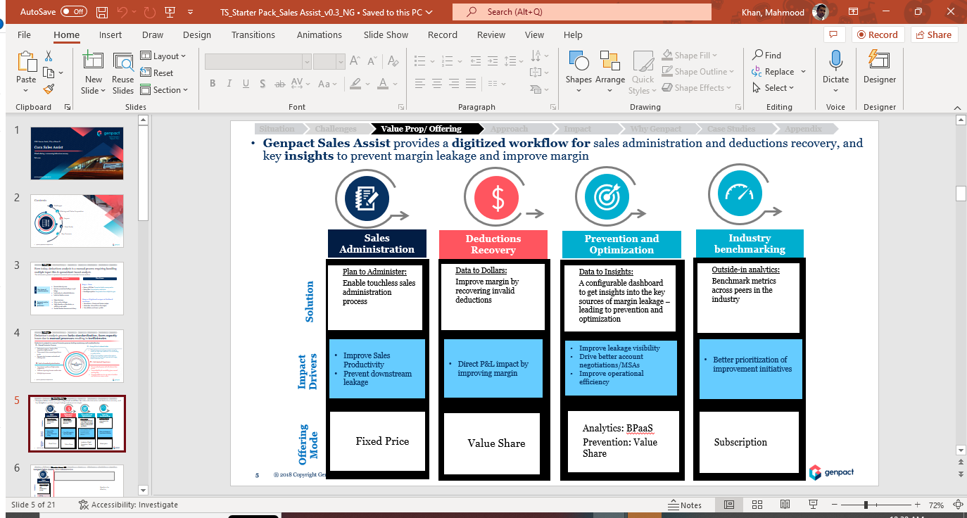

* **Job Duties:** Describe the managerial job duties in greater detail from what was already provided in the initial support letter. To ensure the appropriate amount of specificity, please break down the categories such that no category accounts for more than 40% of the total. **Identify and focus on the managerial decisions required for each job duty.**

|  |  |  |
| --- | --- | --- |
| **Job Duties** | **Additional Details Regarding Job Duties** | **% of time spent on job duty (approx.)** |
| Client relationship | Work with client stakeholders where Digital team is not yet involved and convince them to add Intelligent Automation to their process.  Present them statistical evidences of Digital & Analytics achievements in other areas where digital tools were involved.  Work with client on smooth delivery of existing digital projects and adhere to quality and timely delivery.  Recurring meetings with client are setup to ensure governance model is functioning well and Genpact is able to deliver what was committed in the contract.  Review business case and proof of concept with client and take approval to move forward with the pipeline agreed in statement of work.  Create proposal decks for prospective client based on our experience in the Industry and specific solutions which can help client to solve existing problems or have a positive financial impact. | 30% |
| Project Governance | Co-ordinate weekly Stakeholder Meetings for account  Work on presentation deck and present to Business stakeholders  Work on action items from the review meetings and track them to closure  Create detailed project plan and align team members to share the weekly progress with client and internal stakeholders  Publish financial reports to provide visibility on cost budgeted for the project vs revenue/profit booked for the period. | 20% |
| Digital and Analytics Delivery | Follow the SOW (statement of work) to understand client requirement and create a project plan to address following:   1. Budget/Cost 2. Resource requirement 3. Technical dependencies 4. Skillset requirement 5. Project Timeline   Make sure there are enough work force to meet project requirements for upcoming product releases.  Workload assignments to team members as per the project plan designed and shared with client.  Review the project progress across phases (Quality control & timeliness):  Design, Development, Testing and Deployment | 30% |
| Strategic Decision making | Schedule stakeholder meetings to review offering pipeline for current year and next year.  Publish budget requirements to build new capabilities which can be offered in the market.  Market study to understand latest trends in  business requirements and pipeline for new products.  Work with other client relationship managers to understand client nuances and their requirements which can be addressed by Genpact Digital team. | 20% |
|  |  | **100%** |

* **Organizational Chart:** Provide an organizational chart for the managerial position, including the name and title of each individual listed.

* **People Management:** If the managerial duties involve managing people, provide the following:
  + **Subordinates**: Provide the following information for each individual listed on the organizational chart and provide copies of degrees/transcripts, pay/tax statements for each individual (**provide DETAILED JOB DUTIES i.e. least 2-3 bullets each):**

|  |  |  |  |  |
| --- | --- | --- | --- | --- |
| **Name** | **Genpact Designation** | **Educational Level** | **Salary (annual)** | **Job Duties** |
| Rudraksh Bahri | Management Trainee |  |  | Python Developer: Create python automations to download and consolidate data from ERPs, Portals, shared drives and sharepoint |
| Yash Nagar | Management Trainee |  |  | Data Engineer: Load and Transform data in databases.  Perform analytics on transformed data.  Use visualization tools to present the data to stakeholders. |
| Anirudh Beniwal | Process Developer |  |  | Business driven role: Perform rule based validation on data extracted by the automation tools.  Help the team to work on manual tasks which could not be automated.  Currently works on downloading proof of deliveries and index them if they are in image format. |
| Sunita Bali | Sr. Manager |  |  | Team Manager: Over tolerance team of Kraft Heinz  Responsible for deductions recoveries using predefined process as agreed with client.  Work with Digital team to design the workload management database which can be used by the entire Kraft Heinz team. |
| Dawn Korsick | Manager |  |  | Responsible to validate and recover deductions taken by Kraft’s customers in the specific area of “Chargeback”  Work with Digital team to design the Cora Sales Assist solution for Chargeback |

* + **Managerial Activities:** Confirm the if the managerial role includes the following with respect to the individuals listed in the chart above and provide any available documentation (e.g., instructor feedback forms, time sheet approvals, performance evaluations, etc.):

|  |  |  |
| --- | --- | --- |
| **Yes/No** | **Managerial Task** | **Explanation** |
| **Yes** | ***Authority to hire and fire individuals OR authority to recommend such actions*** | * I have authority to hire people for new positions * I have authority to let people go (fire) in case of non-performance if there was no improvement in performance even after performance improvement plan in coordination with HR |
| **Yes** | ***Mentors or train individuals*** | * I mentored my team members on understanding the business model of our team (Value share deductions) * I trained my team member on Python – Selenium libraries to help automate the web data scrapping * I also helped new team members to understand the accounting basics and how deduction process works as they are from a technical background |
| **Yes** | ***Assigns or delegates work to others, sets others’ work schedules or approves time off*** | Project level tasks  - Support activities  - Action items follow-up delegation  - Low or medium level project status reporting  - I approve daily work hours and time-offs in timesheet system |
| **Yes** | ***Provides performance feedback to others or monitors the status of their project-related activities*** | * I provided annual performance ratings for my team members in HR system * I also used to discuss annual performance feedback with team members and work on their individual growth plan |

* **Functional Management:** If the managerial duties involve managing a **major component or essential function** of the organization:

Provide detailed explanation and documentation as applicable

* + Describe and provide documentation of the major component managed (e.g., Horizontal/Vertical business unit) and the beneficiary’s role in managing it and provide any relevant documentation (e.g., presentations, whitepapers, performance evaluations, etc.)

**<Mahmood>Not applicable**

* + Describe the essential function and the beneficiary’s role in managing it and provide any relevant documentation (e.g., presentations, whitepapers, performance evaluations, etc.)

**<Mahmood>Not applicable**

* **Education & Training**:
  + Provide copies of your all educational (bachelor's degree or higher) degrees AND professional certificates (if any) in PDF format
  + Provide any **RELEVANT training certificates** demonstrating the managerial level training or accentuating your functional role, in PDF format

**<Mahmood>Sent as attachment with RFE response**

* **Employment history with Genpact:**In the table below, provide complete and accurate employment history with Genpact (breakdown of all Genpact Designations (for instance mention exact promotion dates), employment dates with different Genpact entities (as applicable)

|  |  |  |  |
| --- | --- | --- | --- |
| **Genpact Entity** | **Designation** | **From (DD-MMM-YYYY)** | **Until (DD-MMM-YYYY)** |
| Genpact India Pvt Ltd | Assistant Vice President | 18-Oct-2016 | 15-Feb-2020 |
| Genpact LLC | Assistant Vice President | 17-Feb-2020 | Till Date |
|  |  |  |  |
|  |  |  |  |
|  |  |  |  |
|  |  |  |  |
|  |  |  |  |